Waikato Integrated Scenario Explorer – WISE

Process for creation for 2018 Land Use Layer
March 2020
By Tony Fenton, Alchemists Ltd

Background
The Waikato Integrated Scenario Explorer (WISE) model is an Integrated Spatial Decision Support System, which is designed to help examine weakly-structured or unstructured problems characterised by many actors, many possibilities, and high uncertainty.
The WISE model was developed for the Waikato region to support the evaluation and deliberation of strategies and scenarios related in the context of Waikato Regional Council’s long-term planning. It is a tool that helps Waikato Regional Council and other councils evaluate links and trade-offs between economic, environmental and social/cultural outcomes and the cumulative effects of many decisions over space and time (www.creating futures.org.nz).
A key data input to the WISE model is the starting land use layer. This report outlines the process used to create a new starting land use layer for 2018 as part of updating the WISE model to V1.6. It provides information on the datasets used to generate the 2018 land use layer, assumptions made in delineating land uses and limitations to accuracy and use of the final land use output.
Earlier versions of the WISE model have used land use starting points of 2006 and 2013. Land use layers for the Waikato region were created for these timeframes. An overview of the methods used and assumptions is provided here for context.

Classification of land uses
Before the development of a land use map the range of land use classes and criteria for their delineation must be defined. The classification of land uses, as opposed to land cover which is used in LCDB databases, is a complex topic and the type of classification system used and range of land use types depending on user needs (Fenton, 2014).
For the WISE model a comprehensive process to define land use classes was undertaken during its development process. The classification settled on is a balance between the needs of the modelling framework in WISE and the types of land uses of relevance to planners and policy makers. It is acknowledged that this classification might not be the ideal for some uses/users – but it aims to support the majority of user needs.
For the 2018 land use layer a review of classes was undertaken with discussion with WRC Staff and some TAs about the options/needs for other land use classes. It was considered that cost- benefit of adding additional functional land use classes (residential, rural) would not justify and changes to current classes. However, one issue that was identified through feedback from TA’s was how to deal with ‘vacant’ land that primarily occurs within or around edge of existing urban areas. This land is currently not being used for productive uses and is either waiting to be developed or is in the process of being developed into urban land uses. To capture this land correctly an additional vacant land use class has been added to classification – termed ‘vacant – urban land’.
Classification classes used for the development of land use layers for WISE are outlined in Appendix 1.

Previous land use layers
Previously land use layers for the Waikato Region were developed for 2006, for use in WISE Version 1.0-1.3 and 2013, for use in WISE Version 1.4-1.5. A summary of the development history of these layers is provided.

2006 Land Use Layer - WISE V1.0 – V1.3
The initial 2006 land use layer was developed by Landcare Research as part of the initial research project (Creating Futures) under which the WISE model was developed. The WISE model required both accurate classifications of rural land uses and of its urban areas, particularly Hamilton City.
The 2006 land use layer in WISE was developed using a rules based analytical approach using LCDB2 land cover and a range of other spatial layers (Table 1) (i.e. valuation register) to partition land covers (particularly pasture and urban areas) into specific land uses (dairy, sheep and beef, residential, commercial) (Rutledge et al., 2010).
Database | Year
Land Cover Database Version 2 | 2001/2
Environment Waikato Valuation Database | 2008
Environment Waikato Road Verges | 2006
Environment Waikato Railway Corridors | 2006
Topomap Airports | 2000
Department of Conservation- Conservation Estate Map | 2006
Environment Waikato Aquaculture | 2008
Table 1: Input data layers used for generating 2006 land use layer

The process to generate the 2006 land use data layer included:
- formulating the land-use classifications to be used in WISE (Appendix 1)
- compiling and/or developing appropriate input data sets (Table 1)
- devising appropriate rules and algorithms for combining input data sets based on land use classifications
The 2006 process used a Microsoft Access database that linked input data layers to output data layers via a series of rules. Rules stored in the database were passed to a series of custom-built ArcView 3.2 Avenue scripts for processing of the data. The scripts produced a series of 200 × 200-m ESRI grid layers clipped to the area of interest. The logic for the process applied through the rules is shown in Figure 1.
The script used lookup tables which were established for each ‘characteristic’ layer used in the analysis (i.e. LCDB2) these contain ‘inference’ values for every combination of ‘attribute’ in ‘characteristic layer” with each WISE land use class (e.g. LCDB2 Broadleaf Indigenous and WISE Indigenous vegetation is given an ‘inference value of 100).
The script runs through this process for each characteristic layer and then for each cell sums the ‘inference’ values applied to each WISE land class across all characteristics. It then looks for the maximum value of inference across all land classes and applies that land use class to that cell of the raster layer (Figure 1).
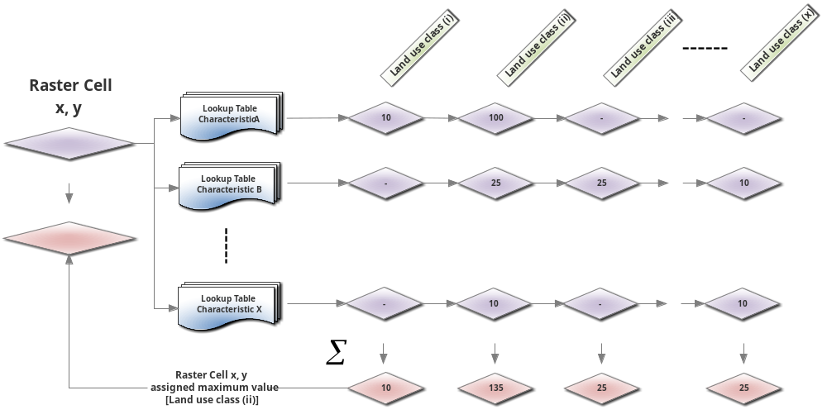
Figure 1: Logic of rules process applied to generate 2006 land use layer

This method sought to provide a repeatable process which could utilise updates to supporting layer to generate new starting date land use layers. Some fine tuning can be achieve through review and refinement of the values in the look up tables.
During the development of the initial land use layer there were some data issues identified with data consistency and validity – particularly with consistency of coding in property valuation data and to a lesser extent with some spatial classifications in the LCDB2 layer (Phynn, D . Pers comm).
As part of development a validation process was undertaken as a final step. This involves cross checking of outputs with some imagery, staff knowledge and other expert input. A number of correction were identified and added to the final processing for the 2006 land use layer. The final output was a 200x200m grid layer with the cell values for land use as defined in Appendix 1.

2013 Land Use Layer - WISE V1.4 – V1.5
The 2013 land use layer was developed by Tony Fenton of Alchemists Ltd for use in WISE V1.4 (Fenton, 2015). The process followed a similar methodology to that used for the initial 2006 land use layer that was developed for WISE. The process utilises three key data sets: Land Cover Database 4 (LCDB4.1); Regional Valuation Database; Agribase (rural land use data)
These are used initially in a rules based ‘Inference Table Process’ in GIS which uses predefined inference tables to assign values to each WISE land use class for each potential data type from each spatial data set, similar to that undertaken for the 2006 land use layer (i.e. Manuka/kanuaka in LCDB4 is given an inference value of 100 for WISE ‘Indigenous’ land use class, and given 0 for every other land use class.).
A summary of the main process steps to develop the 2013 land use layer is shown in Figure 2.
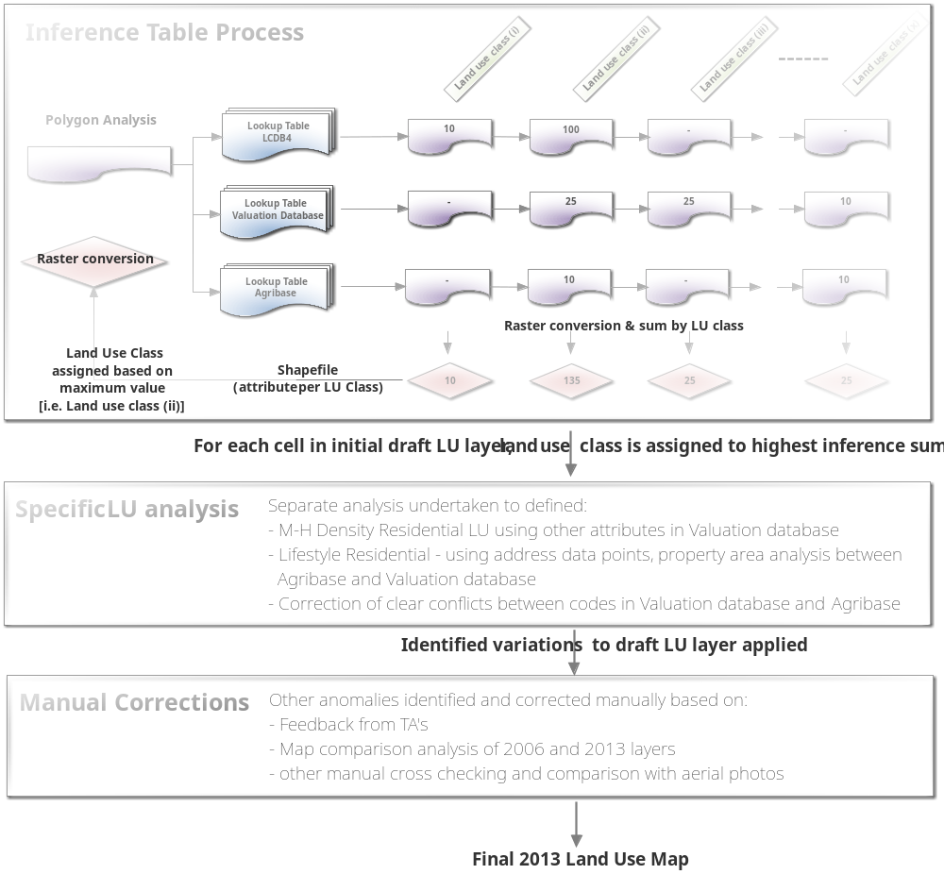
Figure 2: Process Summary of 2013 Land Use layer Development

The inference process step was run repeatedly and inference values adjusted to achieve an optimal outcome. The resulting inference allocations from each data layer are summed and the land use class for each cell in the initial draft land use maps is assigned to the maximum inference value. This inference process was undertaken using a python script in ARCGIS V10.0.
Following this some more specific analysis was undertaken to identify three key residential land uses – low density, medium-high density residential and lifestyle residential. This was undertaken as the ‘Inference process was not sufficient to delineate these correctly. Also there was some conflict between land use codes in the valuation database and Agribase which caused anomalies based on the inference table approach, so this required additional analysis to more correctly delineate rural land uses
The final step was to apply a series of ‘manual corrections’ to the draft land use layer. Identifying these corrections and refining the ‘inference’ process was assisted by feedback on the draft land use map from regional TA’s. Additional corrections were identified by comparison of the draft 2013 and the 2006 land use map, and through some cross checking with 2012 aerial images.
All the ‘inference’ and specific analysis and manual corrections made was undertaken using a 25x25m grid. The final step to produce the 2013 land use layer was to resample up to 100m grid cells using the ‘Majority’ setting in GIS. The final output of the 100m grid was a greater resolution than the earlier 200m grid created for the 2006 land use layer.
During the development of the 2006 land use layer issues were identified with data consistency and validity – particularly with consistency of coding in property valuation data and to a lesser extent with some spatial classifications in the LCDB layer. These issues were much improved in the 2013 update, particularly with the LCDB4, but there were still some anomalies in the valuation codes used. The use of inference process although technically ‘neat’ has some limitations in identifying appropriate land uses particularly where say land cover and valuation coding are at odds. This is discussed further in the next section.
The 2013 land use layer was created to include a 1.6km ‘buffer’ of land use outside the region. This was done to provide additional data to the land use change model in WISE when it is assessing land use change close to regional boundary.
After the completion of the 2013 land use layer an issue that occurred in Hamilton City and to a lesser extent in Cambridge was an under representation of Medium-High Density Residential land use. This was a result of the GIS analytical process on small distributed parcels of this land use in the urban areas. This was manually corrected and the 2013 land use layer updated.

Process For Development of 2018 Land Use Layer
The details of the process used to create the 2018 land use layer for the Waikato Region is outlined in this section.

Input data sets
Five core spatial data sets were used in the development of the 2018 land use layer for the Waikato Region. These are the same type as used in the 2013 process with the addition of Waikato Bioveg layer. The time frames for these dataset were targeted around the June 2018 timeframe (Table 2)
Data layer Name | Data source | Timeframe
Property valuation database (VDB) | Waikato Regional Council | Extracted at June 2018
Agribase | AsureQuality | Extract provided August 2018
Waikato Bioveg Layer | Waikato Regional Council | 2012 – based on LCDB4 and 2012 WRAPS
WRAPS aerial images - 2017/18 | Waikato Regional Council | From summer of 2017/18 to summer 2019/20
LCDB V4.1 | LCR | 2012
Road Parcel | LINZ | Extracted Oct 2018
Table 2: Input data layers used for generating 2018 land use layer

The key difference in data is that the Waikato Bioveg (2012) layer was used to delineate indigenous and exotic forestry and wetlands rather than the LCDB4.1. This was because WRC had undertaken extensive work to improve data from LCDB4.1 based on analysis of aerial photos (2012 WRAPS images). Note – during most of the development of the 2018 land use layer the updated version of LCDB (V5) was not available for use. The LCDB5 was released in early 2020 just prior to finalising this land use layer and hence some cross checking of major land cover types (forestry types) was undertaken.
The data sets in Table 2 represent the best available data for establishing a 2018 land use layer for the region. However, there are some limitation associated with most of the data sets. The key know limitations are:
- The WRAPS aerial images do not represent a ‘tight’ timeframe snapshot of land use. Although referred to here as the 2018 WRAPS – the images across the region were captured over nearly three consecutive summer periods (2017/18, 2018/19 and late 2019)
- The valuation data was extracted from WRC in middle of 2018, but there is some delay in what is actually happening on ground and when is it captured in this database.
- The Agribase data set does not collect a ‘time-bound’ snapshot of agricultural land practices – but instead is a ‘rolling update’ of information across the Region. The currency of the data has been improved since it was first used in the 2013 land use layer development but there are some know quality assurance/currency limitation to its use in this role.

Methodology overview
For development of the 2018 land use layer a variation on the previous ‘inference’ script-based approach was used. This approach used the following reasoning:
- Many of land uses are clearly defined and easy to extract based on VDB LU and VNZ Cat. Improvement codes. But even for these there are often a number of parcels for each land use type that need further assessment to achieve an accurate assessment of land use (i.e. WISE land use Community Services - used VDB 4- codes and extracted from these based on VNZ Cat. Code – but in the end remained a number of parcels that actually fitted better into other LU type (Parks/recreation).
- There were a number of coding conflicts between VDB and Agribase that could not be resolved using a resolved by an ’inference’ /script based approach – so it offered no improvement in efficiency over the method used here.
- The delineation of residential land use classes requires additional parcel size assessment to correctly allocated parcels into one of the three WISE residential land use classes (i.e. <400m² or >400m² <2500m², or >2500m²). An additional issue is parcels that are shared titles (apartment units) needed additional assessment as their areas is commonly coded as ‘0’ in VDB.
- Multi-use codes (i.e 01-09, and 10,20,30 etc) are not always clear cut and require additional assessment of other data (VNZ Cat, Improvements codes or WRAPS) to accurately define.

It was therefore considered more effective to follow a process of firstly extracting obvious data matches that provide high confidence delineations (i.e. residential, indigenous forest, matching rural codes between VDB and Agribase). Then effort could be focused on undertaking more specific detailed assessments for remaining polygons to determine their best land use type fit (Figure 3).
At the time of this analysis the WRAPS photos did not cover the entire Region and there were some small areas still unavailable (strip missing down the west coast and some bits around Mangapiko (east of Lake Waikare), Benneydale, Barryville, and strip down east of Coromandel). Images for these gaps were made available at end March 2020. Some final work was undertaken to check land uses primarily around urban areas (Coromandel settlements, Raglan) and for production forestry, and indigenous clearance.
The extent of the land use map generated for the WISE model is created with a 1600m ‘buffer’ outside the region for terrestrial land uses. This is done to mitigate any boundary affects with the cellular automata modelling approach used in WISE, as the land uses up to 1600m can influence the outcomes of land use change at or near the boundary . Additional property valuation data was sought from Auckland City, Western Bays District, and Rotorua Lakes Councils to inform the land use delineation in this buffer area.
There has also been significant change in recent years with land use change from exotic forestry to pastoral agriculture (mainly dairying). This change was not captured in the WRC Bioveg layer so an additional assessment of the 2018 WRAPS images was undertaken to compare the extent of exotic forestry against the Bioveg dataset. This provided a good spatial assessment of the extent of exotic forestry - although the delineation of the converted land into either dairying or sheep and beef land uses is somewhat subjective based on what could be assessed from aerial images.

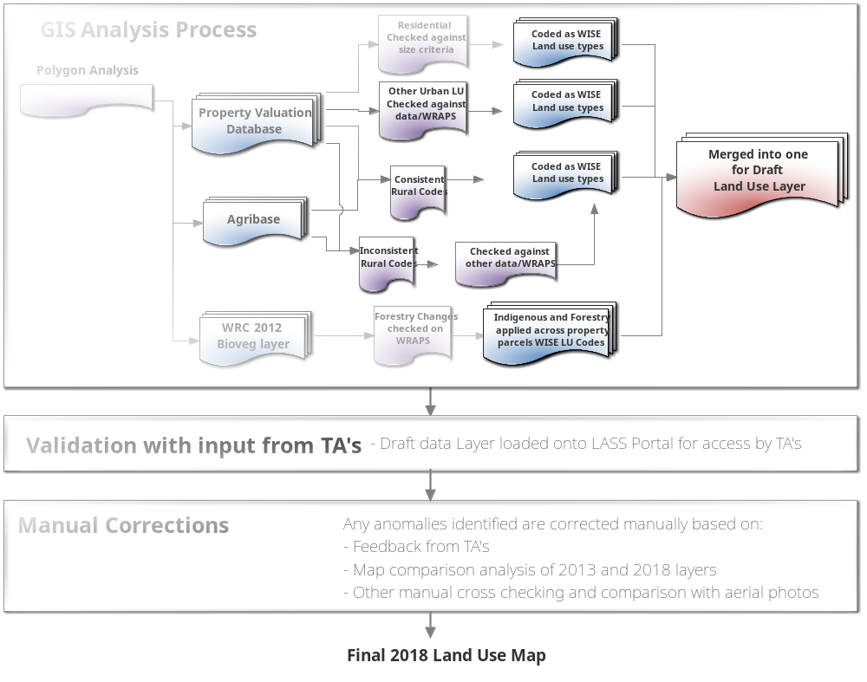
Figure 3: Process Summary of 2018 Land Use layer Development

Specifics processes
For the GIS process working with a range of vector layers required some initial processing of data layers to facilitate the planned analysis process.
Firstly the Agribase data set needed to be processed to remove any overlapping polygons. These exist in the data set where one farm may be made up of 2 or more management units which result in overlapping polygons in some areas of this data set. This processing applied the data from the subset polygon to its spatial area in preference to larger polygon (i.e. in case where large farming entity had large dairy farm but had a smaller enterprise entered separately for part of spatial area in Agribase).
Also an Agribase parcels can often be a combination of Valuation Databse (VDB) parcels under one farm so processing is required to link the attributes of the Agribase to the VDB land parcels. For this classification process we are only interested/able to classify each VDB parcel as a particular farm type. So the process used was to convert Agribase into a raster (5m cells) based in Farm type and then use ‘Zonal Statistics’ (Majority setting) to define the Agribase land use code appropriate for each appropriate land parcel in the VDB. This Agribase code was then added to the attribute table for the VDB dataset for the further analysis.
The WRC BIOVEG_2012 layer was used as the basis for several WISE land use types. This dataset was chosen as it had improved on the information initially provided in LCDB4 through considerable cross checking against the 2012 WRAPS images across the region. The following WISE land use types were extracted from this data set:
- WISE “Other Exotic Vegetation” used the BIOVEG types of ‘Deciduous Hardwoods’, ‘Gorse and Broom’, ‘Mixed Exotic Scrubland’;
- WISE “Forestry” used the BIOVEG types of ‘Forest Harvested’, ‘Pine Forest – closed canopy’, ‘Pine Forest – open canopy’, and ‘Other Exotic Forest’ as the starting point. Note - This data was then assessed in a further process using the 2018 WRAPS to define any ‘pine-to-pasture’ conversion that might have occurred during the 2012-2018 period; and
- WISE “Wetlands” used the BIOVEG types of ‘Herbaceous Freshwater Vegetation’ and ‘Herbaceous Saline Vegetation’.

Summary of processes and assumptions by land use types
The following table is a summary of the processes used and assumptions made in defining and delineating land use types for WISE (as defined in Appendix 1). The key for WISE land use maps is outlined in Appendix 2. See Appendix 3 for the land use codes for the VDB and Agribase layers which are referred to in the following discussion.
This process initially works with the key data sets attribute table codes at a parcel level (Valuation database and Agribase) to define most of the urban and rural productive land uses (Figure 3). This was done by progressively ‘extracting’ parcels from the modified VDB layer using the processes outlined below to create initial separate WISE land use type layers, which were later joined back into one ‘Initial land use’ layer.
Then more spatially specific vegetation types and land uses (from WRC Bioveg and LCDB dataset) are ‘unioned’ across this ‘Initial land use’ data to provide a ‘merged’ land use layer with more specific details on land uses classes within property parcels. This ‘Union’ processing is done in this order because farm parcels can often not be entirely used for purpose defined in VDB or Agribase and can have areas of specific vegetation covers (i.e. indigenous forest, exotic forest).

Land Use Code | Land Use Type | Analysis process and assumptions made
0 | Bare | Initially extracted ‘bare soil’ from LCDB4.1 using “Sand and Gravel”, “Landslide”, “Gravel and Rock” and “Permanent Snow” - then compared this with 2018 WRAPS to see if areas have expanded or shrunk. (This was replaced in final land use layer with bare soils types from LCDB5)
1 | Vacant – urban land | For urban areas where land has been taken out of production but not yet developed and is ‘vacant’ this was classed as ‘Vacant - urban land’. This also included empty residential sections within existing developed residential areas.  The assumption is that these areas are zoned for development and should change readily from vacant land use to required use when WISE model runs.  Identifying these used the vacant VDB codes (99, 29, 79, 89) as each of the other land use types were assessed. This was followed up with some manual checking against the WRAPS images in and around edges of urban areas.
2 | Indigenous | As starting point used WRC Bioveg layer (2012) as this has had additional work undertaken from data in LCDB4, and compared with 2018 WRAPS for any obvious anomalies  For indigenous selected from WRC Bioveg layer based on the LCDB Names -: 'Alpine Grass-/Herbfield', 'Broadleaved Indigenous Hardwoods' , 'Depleted Tussock Grassland', 'Fernland' , 'Flaxland', 'Indigenous Forest', 'Manuka and or Kanuka', 'Grey Scrub', 'Sub Alpine Shrubland', 'Tall Tussock Grassland', 'Sand Dunes', 'Mangrove' . These polygons were coded to WISE Indigenous Forest  The data for LCDB5 was released after the final draft of the 2018 land use layer was completed – some cross checking was undertaken with LCDB5 to identify any anomalies and to correct 2018 LU layer. Also recent work had been undertaken by WRC in some Districts to identify areas of recent vegetation clearance This data was also assessed to capture significant areas of difference (mainly in Taupo, Waitomo, Otorahanga, Waikato district).
3 | Other Exotic | As starting point used WRC Bioveg layer (2012) . For WISE ‘Other exotic’ land use selected from Bioveg layer based on the LCDB Names: 'Deciduous Hardwoods' , 'Gorse and Broom', 'Mixed Exotic Shrubland', 'Sand Dunes - Highly Modified'.  This data was compare with 2017 Wraps for any obvious anomalies around existing the extracted ‘Other exotic’
4 | Wetlands | As starting point used WRC Bioveg layer (2012). For Wetlands land use selected from Bioveg layer based on the LCDB Name: 'Herbaceous Freshwater Vegetation' and 'Herbaceous Saline Vegetation'  This data was compare with 2017 Wraps for any obvious anomalies around existing the extracted ‘Wetlands’
5 | Lifestyle | Initially identified by extracting the following matches of codes from VDB and Agribase data layers:  Matching  - VDB = 20 and Agbase = LIF or Null  - VDB = 21 and Agbase = LIF or Null  - VDB = 22 and Agbase = LIF or Null  - VDB = 29 and Agbase = LIF or Null  Non-matching  - VDB = 20 and Agbase = all other AB codes  - VDB = 21 and Agbase = all other AB codes  - VDB = 22 and Agbase = all other AB codes  - VDB = 29 and Agbase = all other AB codes  Where VDB and Agribase codes matched – LU was coded as Lifestyle. Where codes didn’t match further assessment of VNZ code, improvements and Agribase details were made to determine LU Class.  A large number of these are just parcels that have been subdivided but are still part of adjoining farm activity. For those non-matching extract by ‘other AgBase codes’ where checked against the address layer in rural areas to see if actually a residential use otherwise were given land use based on this Agribase code and not classed as lifestyle.  For WISE Lifestyle land use is defined as > 2500m² and less than 6ha - All suitably coded parcels within these size were coded WISE Lifestyle. Otherwise they were re-coded to either low density residential (<2500m²) or if > 6 ha to the most appropriate rural land use based on aerial images  For 22 codes (multiple dwelling) divided parcel ‘area’ by 2 for those listed with 2 dwellings to determine > or < 2500m² per dwelling to see if some should actually be classed as LD Residential.  For all Vacant 29 Codes extractions - checked to see if have dwellings (used improvements i.e dwelling, or VNZ code ) Away from urban areas these were classed as dominant adjacent rural land use.  VDB Coded 29 parcels in or around urban area/existing lifestyle areas were checked on aerial images and coded ‘Vacant – urban’ if appeared unused.  Where some Lifestyle blocks have a lot of bush i.e. Coromandel - large block (> 6 ha were classed as Lifestyle (4) as later in process Indigenous forest LU would be overlain.
6 | Low Density Residential | For Low Density (LD) residential extracted the following sets from data layers:  - VDB = 90 and 91 and Agbase = 'Null'  - VDB = 92 and Agbase = 'Null'  - VDB = 99 and Agbase = 'Null'  - VDB = 91 and Agbase = all other AB codes  - VDB = 92 and Agbase = all other AB codes  - VDB = 99 and Agbase = all other AB codes  This data was linked to the previous assessment of residential data for Population Density Modelling done in 2016 - using a join by parcel ID - this provides a best estimate of WISE residential land use class for previous residential areas. Data was check for any changes in VDB LU code between earlier work and 2018 data. Then assessed only new properties for 9- VDB codes and sort according to size/dwelling into right residential codes  For 99 (vacant residential) code – assessed if empty section waiting to be developed (in a development) given the “Vacant – Urban” code (Sorted by (capital value - land value) if = '0' then empty section and made 'Vacant - Urban') - only given different code if in WRAPS images it appeared to be used for something - ie grazing, cropping, other exotic veg.  Extracted parcel were also checked for any larger than 2500m² as these were then classed as Lifestyle land use, and any that were less than 400m² as these were classed as MH density residential.
7 | Medium to High Density Residential | As with LD Residential – the data from the previous assessment of residential data for Density Modelling done in 2016 was used in assessment. Data was check for any changes in VDB LU code between earlier work and 2018 data. Then assessed only new properties for 92 (multi dwelling) VDB codes and sort according to size/dwelling into right residential codes.  Also included any new properties with “area” in attribute table = 0 m², as these represent multi-unit titles (several units on the same property and have same parcel ID.  Any Motels/Hotels (93 and 94 in residential codes) were classed as commercial.
8 | Commercial | From 2018 VDB extract LU codes 81-85 as commercial and give land use code for commercial.  Suggested by Market Economics that should check these to see if still commercial as codes are not reviewed unless property is sold. Sorted these by 'area' and checked each site down to 10,000m² against aerials to make sure correct – process was too time consuming to do them all. So for areas < 10,000m² accepted as commercial based on just the VDB codes 81-85.  Extracted 80 (Multiuse - 901 sites and the 08 codes sites [80 of them]) and checked large parcels on WRAPS images and Google street view. Was difficult to sort out 80's as don't know what the multiple use is - assume commercial is dominant so made Code 8. Checked parcels down to about 1200m² - split off parts of some parcels and made other land uses based on aerial photos.  Extracted Code 89 (vacant - 399 sites) separately and manually checked most and provide with best LU Code - looked at ‘improvements’ code for guidance. Many vacant sites were used as car parking in CBD's – so coded these as Utilities LU Type (21). Others were classed as “Vacant – urban land”  Some commercial properties that are rest home/care facilities - decided best to split out areas that look residential and make LD or MHD Residential - and communal facilities or rest home/hospital areas made commercial (after discussing with Market Economics)  Commercial accommodation (motels/hostels) also commercial (VDB Codes 93, 94, 95 and 96 in residential codes - Extracted all of these and check aerial photo / google street maps to determine best LU Type code
9 | Community Services | Extracted all LU Codes '4-' from VDB  Used VNZ Cat. codes to extract suitable Community Services uses (i.e churches, marae, childcare centers, elderly Care, education. Finally any remaining ‘4-‘ code in an urban area with a building on was made Comm Services (9) many of the other parcels coded 23 for Parks and Recreation .  There were some difficult coding to sort out under these as variety of things coded under this (e.g. stop banks, golf courses, water supply catchments). Took some time to sort out realistic representation.  There is also some mix between WISE ‘Community Services’ and ‘Parks and Recreation’ mixed in VDB between 4- and 5- codes ( i.e. clubs bowling, velodrome etc - tended to put Sports facilities into Parks and Recreation)
10 | Horticulture | The VDB code 15 is used for both market gardens and horticulture. So undertook the following process:  - Extracted all parcels with VDB code 15.  - From this extracted for Horticulture any parcels with Agribase codes for FLO, NUR, FRU and VIT - saved as initial WISE Horticulture land use  - Then extracted for Vegetable Cropping all AGB codes for VEG. - saved as Initial WISE Vegetable Cropping land use (WISE code 12).  - For the remaining parcels with the VDB 15 code - these were then analysed to sort into either the Horticulture or Vegetable Cropping layers. Where VDB land use code, VNZ Cat code and Agribase agreed they were made this land use. The remaining were cross checked against 2018 WRAPS images.
11 | Biofuel Cropping | Not assessed for 2018 Land use layer
12 | Veg cropping | See process notes for Horticulture above  The key difficulty here using WRAPS images was trying to separate out what was maize cropping (Other cropping) from possible Vegetable cropping – a best judgement approach was applied based on visual cues (e.g. straight rows, clusters of rows, variation in spacing/colour of rows)
13 | Other Cropping | Extracted ARA from AgBase and checked in 2018 WRAPS  When manually checking the WRAPS images for other land use types – areas that appeared cultivated and in cropping and not classed as vegetable cropping were classed as Other Cropping.
14 | Dairying | Firstly extracted into separate file VDB = 11 (Dairy) and AB = DAI and DRY (5404 parcels). Then to check validity - accepted those VDB Code 11 and either VNZ cat. DFA or DFB and parcel has a dwelling and is DAI or DRY for AgriBase – made WISE LU Code 14.  Then made anything with DFC, DFD, DFE and DFF dairying - many of these have dairy sheds and there is no way to tell whether or not they are dairying support or some other use. Checked 38 parcels that had other non-"D" VNZ Cat codes on WRAPS and made judgement as to use.  Then extracted into separate file VDB = 12 (Stock Finishing) and AB = DAI and DRY (498 parcels) - accepted those with VDB Code 12 and either VNZ cat. - DFA, DFB, DFC, DFD, DFE and DFF and had a dwelling and is DAI or DRY for AgriBase as WISE Dairying LU Code 14.  Extracted into separate file VDB = 14 (Store Livestock) and AB = DAI and DRY (33 parcels) - to make sure valid checked against WRAPS and coded accordingly giving best estimate of use.  VDB Code 11 (Dairying) and other AgriBase codes (Not dairying) – worked through process of assessing VNZ Ct. codes and then WRAPS to determine best land use.
15 | Sheep and Beef | Extracted VDB 12 (Stock Finishing) and 14 (Store Livestock) codes with AgriBase BEF, SNB, DEE SHP – Assumed correct match and made WISE LU Sheep and Beef (coded 15).  For VDB Code 12 and 14 and all other AgriBase codes (excluding dairying, sheep and beef and other agriculture codes assessed seperately) – For these parcels worked through process of assessing VNZ Ct. codes and then WRAPS to determine best land use.
16 | Other Agriculture | Extracted all Parcels with AgBase codes of GOA, ALA API, DOG, FIS, HOR, PIG, POU. Also added any VDB 16 (specialist livestock) codes.  Then checked for anomalies by - removing any '6-' codes,  Where both codes supported made WISE LU Code 16 otherwise checked against 2018 WRAPs
17 | Forestry | As starting point used WRC Bioveg layer (2012) - used classes ‘Forest Harvested’, ‘Pine Forest – closed canopy’, ‘Pine Forest – open canopy’, and ‘Other Exotic Forest’ to define initial land use type layer. Note: at this time LCDB5 was not available.  As there has been considerable interest in deforestation and change in recent times. Then undertook a detailed assessment of this initial Forestry layer against the 2018 WRAPS images to identify areas that looked to have been cleared and converted to other land uses or areas that had been recently planted in forestry.  When looked for signs if place is being replanted or not focused on things like presence of water troughs or animal trails following contours, no separate fence, slash piled up for burning vs lots of slash, regenerating vegetation vs grass.  In terms of new forestry only put in sites that appeared to have been planted recently - not small blocks that were 'missed' as part of the 2012 bioveg process  Also added in LCDB4 areas of forestry for the 1.6km buffer around outside of Region  This analysis does not cover riparian plantings  The data for LCDB5 was released after the final draft of the 2018 land use layer was completed – some cross checking was undertaken with LCDB5 to identify any anomalies and to correct 2018 LU layer for exotic forestry.
18 | Manufacturing | Extracted VDB Land Use codes 71-78 as initial Manufacturing layer (3434 properties)- However a lot of these can actually be Commercial businesses (Market economics – pers comms.) – i.e they are selling services or products and not actually making products. (e.g. lot of properties in Frankton, Hamilton)  so too a lot of time to go through and check to get this as realistic as possible - did this by checking main commercial industrial areas and looking at clusters in areas - didn't assess every polygon. But did check a lot.  give land use Code 18 - if found to be Manufacturing -  From 2018 VDB extracted 79 (vacant - 965 sites) separated and manually check and provide with best LU Code.  Extracted Multi use Code 07 and 70 (MultiUse - 889 sites) separated and manually check and provide with best LU Code - looked at large areas sites first down to - check improvements codes. (A lot of these are actually Commercial - they are business that sell products or services - not actually manufacturers)
19 | Marine | Defined as the area outside coastline and within Waikato Region (based on area define in 2013 WISE land use map)
20 | Aquaculture | Based on the WRC Aquaculture GIS layer
21 | Utilities | Extracted all VNZ Cat. 'U' Codes from VDB. Then extracted any remaining '6-' Land use codes and added to these. Finally extracted any remaining '3-' codes and added to this layer  Check for anomalies by looking at very small areas and then very large to check if codes were correct.
22 | Mines and Quarries | Extracted VDB code 18 - checked areas and boundaries.  Also added any other quarry/mine areas manually when undertaking manual checking for other land use types across 2018 WRAPS images
23 | Urban parks and Recreation | From VDB Extract those with Codes 05, 53, 55 and 59.  The VDB ‘5-‘ codes are a bit of a ‘catch all’ as they cover all sorts of land types – such as most Department of Conservation land is classed as ‘5-‘ code. This does create some issues when the ‘Initial land use’ layer is ‘unioned’ with vegetation covers (I.e. Indigenous) as you can end up with lots of small parcels classified as Parks around edges – especially where Bioveg boundary doesn’t match property parcel boundary.  See notes under Community Services – some cross over between VDB LU Codes ‘4-‘ and ‘5-‘ in actual usage.
24 | Freshwater | From LCDB4.1 - used Lakes and Ponds, and River classes - added to WISE LU_Code of 24
25 | Airports | Extract Airports from VDB Code 35 / Also add Airports from Topo50
Note: The other two land use classes (‘area outside region’ and ‘marine areas outside the region’) were not separately assessed. These were simply extracted from the 2013 land use map (as 100m grid cells) and merged to the 2018 data once it had been converted into a 100m grid raster to provide the final map for use in WISE Model.

ORDERING LAYERS
After the processing outlined above was completed the draft land use layer was created by:
- Merging together all the ‘initial land use layers’ extracted from the joined VDB and Agribase dataset. These covered all property parcels in VDB
- Then add in the LINZ road network
- The following land layers were then overlaid onto this data:
  - Forestry layer based on 2018 revision of Bioveg layer data
  - Bare surfaces from LCDB5
  - Wetlands from Bioveg layer
  - Other Exotic Vegetation from BioVeg layer
  - Indigenous Vegetation from BioVeg layer
- Finally the LCDB4 waterbodies was this provided almost complete coverage of region (some small gaps existed along waterways etc)

For WISE land use map (at 100m raster grid) a manual correction was made to the Medium-High Residential land use class - this was to correct for a reduction in this land use as a result of resampling to the 100m grid (the relatively small disperse MHD residential parcels tend to reduce with resampling) . Where needed LD residential grid cells were changed to MHD residential, based on MHD residential parcels density, to ensure about the same area of this land use type was in final WISE land use grid as in parcels in VDB (see details in Appendix 4).

The final additions to the WISE land use map were the marine area, aquaculture areas, and area outside of region.

Validation of land use layer
The draft land use data was made available to the territorial authorities to provide feedback on the proposed land use in 2018. Feedback from staff was used to correct a number of codings and provide the final land use layer

Caveats to land use layer
This 2018 land use layer represent a ‘best effort’ to delineate the land use in Waikato region in June 2018. As outlined above each of the data sets used for this process have some limitations. Also there have been a number of assumptions made in way the data is process as defined in the table above.
The following is a number of caveats that should be kept in mind when using this land use layer:
Residential land use:
- The residential land use types are based on the ‘parcel area/dwelling’ definitions used for the WISE model (<400m² for MHD residential, >400m² and <2500m² for LD residential, and >2500m² for Lifestyle residential) .
- The delineation between commercial and manufacturing/industrial land uses has taken a more defined approach in this land use layer. Significant areas of urban land are classes in VDB as industrial but from the WISE land use definition many are actually commercial in their activity (the sell products or services). This has resulted in a significant difference in the area of manufacturing and commercial land in the 2018 land use map (more commercial land, less manufacturing land) compared with earlier 2013.
- In urban areas land parcels can have multi-uses (commercial and residential, commercial and industrial) however for the WISE land use map only one land use can be defined so this has required some judgement and subjectivity to define the dominant land use type for property parcels.
Rural land uses:
- There are some coding limitations with datasets used – particularly Agribase which uses a ‘rolling’ update.
- Property parcels are defined in most cases as only one WISE land use type – this is not always the case for an actual farm business on the ground – so represents a ‘simplification’ of use based on dominant use.
- For WISE the Dairying land use is classed as being both functioning dairy farms and dairy support. The capturing of this land use is only as accurate as coding in datasets used. During manual checking anomalies in the codes where identified and correct ed where possible. Delineating dairy support is ‘identified’ by some of the database codes (i.e. VNZ Cat. – to identify properties as dairy support (no dairy shed present on property)) otherwise some subjectivity is applied when manual assessments/corrections using imagery were made
- The assessment of existing exotic forestry is an improvement on the 2012 Bioveg data as considerable manual checking was undertaken. However, there is some subjectivity in trying to establish areas which have been recently cleared from forestry. Areas seen ploughed and fenced were subjectively defined as either dairying or sheep and beef based on adjacent land use, paddock size, presence of stock etc. There were areas of uncertainty when it was hard to distinguish if areas might be going back into forestry. Also some of the large areas recently cleared identifying areas that might become riparian margins or be replanted is not always clear. These factors add a level of uncertainty to actual extent of forestry and pastoral land uses.

Finally the datasets used were targeted around the June 2018 timeframe, but it is recognised that the data used has a wider range of timeframes which could influence the resulting land use delimitation.

Differences between 2012 and 2018 Land Use
For transparency and to inform the use of this data layer a comparison with the earlier WISE 2013 land use layer is provided in Table3
Grid No | Land Use Type | Area in 2013 (ha) | Area in 2018 (ha) | Comments on Differences
1 | Vacant - Urban land | - | 4688 | Area the previously was in other residential/urban classes
2 | Indigenous Vegetation | 663628 | 702078 | The Bioveg layer work has defined a lot more areas within what was previously classed as pastoral land uses in 2013, and this work has also defined more indigenous areas within plantation forestry.  These also appears to be a few anomalies in the 2013 land use layer – most significantly some large areas of Alpine grass herbfield around Ruapehu/Tongaririo were miss represented as Bare ground in 2013.
3 | Other Exotic Vegetation | 10602 | 52260 | For this land use type also the Bioveg layer work has defined a lot more areas within what was previously classed as pastoral and exotic forest land uses in 2013.
4 | Wetland | 558 | 19616 | Wetland extent was updated as part of 2012 Bioveg work and also the Kopuatai Peat dome and a large part of Whangamarino are now classes as wetland was previously Indigenous Veg.
5 | Residential - Lifestyle Blocks | 34371 | 39445 | As expected – although some of this class in 2013 would have been ‘vacant urban’
6 | Residential - Low Density | 12290 | 13064 | As expected – although some of this class in 2013 would have been ‘vacant urban’
7 | Residential - Medium to High Density | 282 | 521 | Expected to have increase – but for 2018 layer undertook adjustment for all TA’s to correct ‘grid’ effect when downscale to 100m – in 2013 only did this for Future proof area.
8 | Commercial | 768 | 2175 | More areas classed as commercial that have ‘industrial’ VDB code in 2018
9 | Community Services | 1871 | 2334 | As expected – more confidence in 2018 extent due to extent of manual checking.
10 | Horticulture | 2092 | 3403 | As expected – more confidence in 2018 extent due to extent of manual checking.
11 | Biofuel Cropping | - | - | No present in either layer
12 | Vegetable Cropping | 5991 | 6315 | As expected – more confidence in 2018 extent due to extent of manual checking.
13 | Other Cropping | 3376 | 8400 | Significant change but more confidence in 2018 extent due to extent of manual checking.
14 | Dairy Farming | 647164 | 681327 | There have been conversions to dairying at the expense of forestry and sheep and beef, but also expect that Agribase and VDB coding is improved. Additional manual checking has also identified more areas thought to be dairy support.
15 | Sheep, Beef or Deer Farming | 636288 | 514891 | Part of reduction is conversion to dairying or being classed as dairy support, an probably more has been classed as Other Agriculture and some conversion to forestry.
16 | Other Agriculture | 7204 | 12760 | Significant increase – expect the process in 2018 of using successive extractions from data set and more checking of coded ‘dairying’ and ‘sheep and beef’ uses rather than ‘inference’ method in combination with better Agribase dataset has driven difference – more confidence in 2018 numbers.
17 | Forestry | 309161 | 283084 | There have been ‘swing and roundabouts’ for forestry – with large areas being cleared for dairying and some sheep and beef, but there has also been significant planting of forestry in the Taupo catchment and some in part of the King Country. Significant manual checking against the WRAPS images was undertaken so have higher level of confidence in the 2018 results.
18 | Manufacturing | 2522 | 1928 | The has been some increase in Manufacturing land use areas - around Future proof councils - but this has been offset by better delineation of Commercial use previously classed Manufacturing.
21 | Utilities | 12380 | 4666 | Grid process used in 2013 over estimated roads and also had extra areas around power stations (Wairaki)
22 | Mines and Quarries | 2721 | 2697 | As expected
23 | Urban Parks and Recreation | 4177 | 4174 | As expected
Table 3: Comparison between 2018 and 2013 land use layer (Note: These exclude the 1.6km buffer around region that is shown in land use maps)

Appendix 1: Classification of Land USe for WISE Model
Cell Value | Type | Class | Code | Description | Examples | Rationale
0 | Vacant | Bare Surfaces | BSF | Sand, unvegetated sand dunes, bare rock, ice and snow, large unvegetated erosion scars and alluvial flats, permanent exposed soil not related to Mine or Quarry activities | Beaches and sand dunes on the Coromandel and West Coast, The Volcanoes of Tongariro National Park. | Covers significant parts of Waikato coastline and around mountains. Is a passively dynamic land use of natural causes
1 |  | Vacant – urban land |  | Land awaiting urban development (residential, lifestyle, manufacturing, commercial) has been zoned and/or subdivided and is not currently being used for any other use – sitting vacant or under development. | Empty sections in recent residential developments (Rototuna, Cambridge north, Pauanui waterways) or large industrial areas under development (Rotokauri) | This land use type captures land in and around urban areas that is under development or will likely be developed shortly. This type of land does not fit clearly into any of the other classes as defined.
2 |  | Indigenous Vegetation | IDV | Predominantly native vegetation such as indigenous forest, shrubland, tussock and mangroves | Indigenous forests, mānuka/kanuka, flaxland, fernland, etc. | “Native bush” is an iconic part of the NZ landscape; also indigenous forest has second highest coverage in Waikato region
3 |  | Other Exotic Vegetation | OEV | Predominantly exotic/non-native vegetation not intentionally planted for production of timber products | Wilding pines, willows, deciduous hardwoods, gorse, blackberry, heather, matagouri? | Allows for areas where non-natives exist or can colonise after management for economic gain stops (similar to abandonment in other RIKS models but that concept does not fit as well in NZ)
4 |  | Wetland | WLD | Permanent saline or freshwater wetlands and their associated non-woody vegetation | Whangamarino; Torehape; Kopuatai; Some estuarine margins. | Although officially protected, inclusion as vacant state allows for possibility of further loss or restoration, both of which occur; difficulty with resolution as many wetlands may fall below the resolution of the model
5 | Function | Residential – Lifestyle Blocks | RLB | Very low density, detached, private, single-family dwellings on lots >0.25 ha but usually no larger than 8 ha; usually located in peri-urban or rural areas | Developments around Matangi, Tamahere, River Road north of Hamilton and NW of Cambridge. | For the Waikato, 2 classes (low/high) for depicting lifestyle/periurban vs. urban situations would likely suffice; 3 classes are recommended for easier transferability to other regions, such as Auckland or Wellington, where 3 classes better capture the range of densities available or allows for more scrutiny of intensification
6 |  | Residential – Low Density | RLW | Areas with 5–25 dwellings per hectare, typically dominated by detached, single-family dwellings or duplexs; lot sizes typically from 500–1000² m but can be up to 2500² m | This is typical New Zealand residential development (i.e. "the Kiwi quarter acre dream") built mostly prior to 2000.
7 |  | Residential – Medium to High Density | RMH | Areas with >25 dwellings per hectare, typically dominated by multi-unit buildings like townhouses, apartment complexes, or high-rises | Sherwood Vale in Hamilton (along Ruakura Road); new developments north of Hamilton; apartment blocks
8 |  | Commercial | CML | Wholesale and Retail Trade, Accommodation/Restaurants/Cafes, most communication services, Finance/Insurance and Property Services; Services to Agriculture; Hunting and Trapping | The Base, any CBD or shopping centre in Hamilton or other city/town | A key land use class in terms of its influence on other urban land uses. Typically is the centre of any urban area
9 |  | Community Services | CMS | Government Administration and Defence; Education; Public Safety; Health Services; Public Film, Video, Radio and Television services; Libraries, Museums, Arts and services to the Arts | Waikato District Hospital, Waikeria Prison (Buildings), Hamilton Boys High School, Police Station | A key land use in the service of urban areas. Typically borders commercial and is actively dynamic in expanding urban areas
10 |  | Horticulture | HOR | Production of fruits, nuts, seeds and flowers and other ornamental plants; includes nurseries and viticulture | Vilagrads and Mystery Creek Vineyards; Sunfruit Orchards | Pastoral based production is the dominant land use in the Waikato Region, followed by forestry. Cropping and horticulture generally make up a smaller part of the region although they can be significant in terms of their effects on land and water. Biofuel cropping is included to allow for expansion in future scenarios
11 |  | Biofuel Cropping | CPB | Production of plants for energy supply | Rape seed, Jatropha, Beets, Sorghum, Coppice plantations, maize? (see issues), etc.
12 |  | Vegetable Cropping | CPV | Production of plants and roots for the purpose of vegetables for human consumption. Typically involves heavy soil disturbance as part of succession cropping | Land around Pukekohe
13 |  | Other Cropping | CPO | Production of other crops such silage, barely, maize, wheat, tobacco, hops; fungi. Usually involve less disturbance of the soil and rotated on an annual basis | Various rural locations around the region
14 |  | Dairy Farming | DFM | Land used for the pastoral production of dairy milk or for support of that land use | Most of Waikato's low-lying pastoral landscape
15 |  | Sheep, Beef or Deer Farming | SBD | Pastoral production of sheep and/or beef and/or deer | Predominantly hill country farming such as commonly found around Te Kuiti
16 |  | Other Agriculture | OAG | Other agricultural activities such as beekeeping, horse, pig, poultry mixed livestock and other livestock farming | Equine industry around Cambridge; Goats, Pigs, Chickens, Ostriches, Alpaca
17 |  | Forestry | FTY | Land used for the growth and harvesting of wood, primarily Radiata Pine but also may include other exotic or indigenous species | Kaingaroa or Kinleith Forest. Various smaller private forestry blocks on farmland
18 |  | Manufacturing | MFG | Production and storage of goods such as wood/paper, textiles, clothing, footwear, foods, beverages, petroleum, coal, chemicals, metals and non-metals, machinery, equipment and furniture; Printing and publishing | Kinleith Pulp and Paper Mill; Dairy Factories; Urban industrial areas | A key land use in terms of its interactions with primary production land uses and the urban land uses serving the manufacturing area
19 | Feature | Marine | MAR | Estuarine and open coastal water out to the 12NM regional boundary | West Coast, Firth of Thames, Coast around Coromandel Peninsula, Raglan Harbour, Whangamata Estuary | A significant part of the Waikato region generally deemed static but could change to a vacant state if aquaculture became a function. Has neighbourhood influences on some land uses
20 |  | Aquaculture | AQC | Production and cultivation of aquatic animals and plants; both salt and fresh water | Mussel farms off Thames coast. Huka prawn park | A developing industry in the Waikato Region. Difficult to model as a function at this stage due to a lack of information but could be changed to a function in later versions
21 |  | Utilities | UTL | Infrastructure for generation, transmission, distribution, storage, treatment or manufacture of electricity, gas, water supply and wastewater treatment. Also includes large infrastructure associated with transportation but not airports | Huntly Power Station, Karapiro Dam, Hamilton Wastewater Plant, Wairakei Geothermal Power Plant, Frankton Railway Station | Critical in keeping the built human environment although tends to have only minor interactions with neighbouring land uses
22 |  | Mines and Quarries | MAQ | Mining and quarrying operations and their solid waste products. Includes coal, oil and gas extraction and exploration activities | Huntly Coal Mine, Waihi Gold Mine; various sand & gravel quarries | Covers significant parts of the Waikato Region. A key employer
23 |  | Urban Parks and Recreation | URP | Areas set aside for recreation, leisure activities, or aesthetic enjoyment; includes Parks and Gardens, Sports Fields and facilities, Gambling and Other Recreation services. Excludes conservation estate land such as National or State Forest Parks | Claudelands Park, Cambridge Town Belt, Hamilton Gardens, Waikato University grounds, Waikato Stadium, Te Rapa Racetrack | Has strong impacts on urban land use dymanics
24 |  | Fresh Water | FRS | Permanent fresh water bodies including lakes, reservoirs, dams and ponds over 4 ha and rivers wider than 200 m | Lake Taupo, Lake Karapiro, various smaller lakes and ponds 4ha minimum | Covers significant parts of the region and has some interaction with some neighbouring land uses
25 |  | Airports | APT | Large airports used for domestic or international flights and their directly associated structures and buildings. Excludes small rural airports and airstrips used only for recreational or primary industry purposes | Hamilton, Taupo and Thames Airports | Critical in servicing large urban areas. Has immediate interactions with some neighbouring land uses

Appendix 2: Key for 2018 Land Use Map
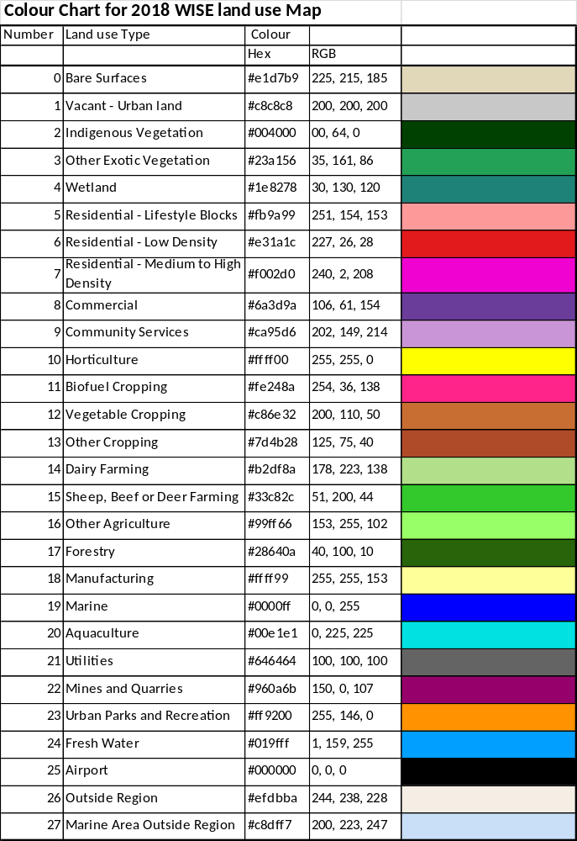

Appendix 3: Land use Codes from Valuation Databse and Agribase
Codes for Valuation Database
Table 6: Primary level use codes for land use data
Code | Explanation
0 | Multi-use at the primary level
1 | Rural industry
2 | Lifestyle
3 | Transport
4 | Community services
5 | Recreational
6 | Utility services
7 | Industrial
8 | Commercial
9 | Residential

Table 7 Secondary level use codes for land use data
Primary level code | Description | Secondary level code | Primary level code | Description | Secondary level code
0 | Multi-use at primary level |  | 1 | Rural industry
 | Vacant or intermediate | 0 |  | Multi-use within rural industry | 0
 | Rural industry | 1 |  | Dairy | 1
 | Lifestyle | 2 |  | Stock finishing | 2
 | Transport | 3 |  | Arable farming | 3
 | Community services | 4 |  | Store livestock | 4
 | Recreational | 5 |  | Market gardens and orchards | 5
 | Utility services | 6 |  | Specialist livestock | 6
 | Industrial | 7 |  | Forestry | 7
 | Commercial | 8 |  | Mineral extraction | 8
 | Residential | 9 |  | Vacant | 9

Primary level code | Description | Secondary level code | Primary level code | Description | Secondary level code
2 | Lifestyle |  | 3 | Transport
 | Multi-use within lifestyle | 0 |  | Multi-use within transport | 0
 | Single unit 1 | 1 |  | Road transport | 1
 | Multi-unit 2 | 2 |  | Parking | 2
 | Vacant | 9 |  | Rail transport | 3
 |  |  |  | Water transport | 4
 |  |  |  | Air transport | 5
 |  |  |  | Vacant | 9

Primary level code | Description | Secondary level code | Primary level code | Description | Secondary level code
4 | Community Services |  | 5 | Recreational
 | Multi-use within community services | 0 |  | Multi-use within recreational | 0
 | Educational | 1 |  | Entertainment | 1
 | Medical and allied | 2 |  | Active indoor | 2
 | Personal and property protection | 3 |  | Active outdoor | 3
 | Religious | 4 |  | Passive indoor | 4
 | Defence | 5 |  | Passive outdoor | 5
 | Halls | 6 |  | Vacant | 9
 | Cemeteries and crematoria | 7
 | Vacant | 9

Primary level code | Description | Secondary level code | Primary level code | Description | Secondary level code
6 | Utility Services |  | 7 | Industrial
 | Multi-use within utility services | 0 |  | Multi-use within industrial | 0
 | Communications | 1 |  | Food, drink, and tobacco | 1
 | Electricity | 2 |  | Textiles, leather, and fur | 2
 | Gas | 3 |  | Timber products and furniture | 3
 | Water supply | 4 |  | Building materials other than timber | 4
 | Sanitary | 5 |  | Engineering, metalworking, appliances, and machinery | 5
 | Other | 6 |  | Chemicals, plastics, rubber, and paper | 6
 | Postboxes | 7 |  | Other industries, including storage | 7
 | Vacant | 9 |  | Depots and yards | 8
 |  |  |  | Vacant | 9

Primary level code | Description | Secondary level code | Primary level code | Description | Secondary level code
8 | Commercial |  | 9 | Residential
 | Multi-use within commercial | 0 |  | Multi-use within residential | 0
 | Retail | 1 |  | Single unit excluding bach | 1
 | Services | 2 |  | Multi-unit | 2
 | Wholesale | 3 |  | Public communal unlicensed | 3
 | Offices | 4 |  | Public communal licensed | 4
 | Car parking | 5 |  | Special accommodation | 5
 | Vacant | 9 |  | Communal residence dependent on other use | 6
 |  |  |  | Bach | 7
 |  |  |  | Car parking | 8
 |  |  |  | Vacant | 9

Codes for Agribase
Farm_Type_Code | Farm_Type_Name
ALA | Alpaca and/or Llama Breeding
API | Beekeeping and hives
ARA | Arable cropping or seed production
BEF | Beef cattle farming
DAI | Dairy cattle farming
DEE | Deer farming
DOG | Dogs
DRY | Dairy dry stock
EMU | Emu bird farming
FIS | Fish, Marine fish farming, hatcheries
FLO | Flowers
FOR | Forestry
FRU | Fruit growing
GOA | Goat farming
GRA | Grazing other peoples stock
HOR | Horse farming and breeding
LIF | Lifestyle block
NAT | Native Bush
NEW | New Record - Unconfirmed Farm Type
NOF | Not farmed (ie idle land or non-farm use)
NUR | Plant Nurseries
OAN | Other livestock (not covered by other types)
OPL | Other planted types (not covered by other types)
OST | Ostrich bird farming
OTH | Enterprises not covered by other classifications
PIG | Pig farming
POU | Poultry farming
SHP | Sheep farming
SNB | Mixed Sheep and Beef farming
TOU | Tourism (ie camping ground, motel)
UNS | Unspecified (ie farmer did not give indication)
VEG | Vegetable growing
VIT | Viticulture, grape growing and wine
ZOO | Zoological gardens

Appendix 4: Adjustment of Medium-High Density residential areas in final 100m land use grid for WISe
In developing the 2013 land use layer for WISE it was found that MHD residential was particularly underrepresented in the large urban areas. This is a result of this land use type often being a scattered arrangement of parcels within larger areas of LD residential – so when the GIS process is used to reduce the resolution to 100m cells the MHD residential land use type can end up being underrepresented depending on the pattern of the parcels in each urban area. At that time the decision was made to edit the final 100m land use map for WISE to bring the MHD residential areas in WISE map back close to the sum of the areas of MHD residential polygons in each TA. For 2013 map this adjustment was only undertaken for the Future Proof Councils.
For this 2018 land use maps this adjustment process was undertaken for all the TA’s that had significant areas of MHD residential land use. The table below outlines the areas based on polygons/parcels, resulting area in initial draft WISE 100m cell map and the adjusted result in the final WISE land us map.
Territorial Authority | Total Area in Parcels (ha) | Area in initial 100m grid (ha) | Area in final WISE land use map (ha)
Thames Coromandel | 89 | 35 | 83
Hauraki District | 13 | 0 | 12
Matamata Piako | 22 | 2 | 21
Waikato District | 27 | 10 | 27
Hamitlon City | 245 | 95 | 244
Waipa District | 82 | 55 | 80

References
Fenton T (2014): Land Use Classification for Integrated Spatial Decision Support Systems: A review of methodologies for updating land use layer for WISE model. Prepared for Waikato Regional Council. Alchemists Ltd.
Fenton T (2015): 2013 land use – Layer development for WISE V1.4. Prepared for Waikato Regional Council. Alchemists Ltd.
Rutledge DT, Cameron M, Elliott S, Hurkens J, McDonald G, McBride G, Phyn D, Poot J, Price R, Schmidt J, van Delden H, Tait A, Woods R. (2010): WISE – Waikato Integrated Scenario Explorer, Technical Specifications Version 1.1. Landcare Research Report LC117 produced for Environment Waikato on behalf of the ‘Creating Futures’ project.

See www.creating futures.org.nz
See Appendix 3 for code definitions
Rating Valuations Rules 2008 | LINZS30300 Version date | 1 October 2010 Office of the Valuer-General | Land Information New Zealand

